CS2S567 Professional Practice and Employability:
Team Based Software Development Workshop

Team Portfolio

By
Jessica Fealy, 18024092
Ben Harrison

Team Number | 2
Team Task | Create a PIM system
Team Members | Jessica Fealy  Ben Harrison  Komal  Harry  Ed

Contents
Contents 2
Weeks 1 & 2 3
Weeks 3 4
Weeks 4 5
Personal QA/ISSUE TRACKING Activity Overview Log 6
Appendix 9
Appendix 1 – GUI Plan 9
Appendix 2 – Discord creation 9
Appendix 2 – Team meetings time discussed 10
Appendix 3 – Spoken about what tasks are required to be completed 10
Appendix 4 – Trello board 11
Appendix 5 – Team work assignment 11
Appendix 6 – Week 4 work assignment 11
Appendix 7 – Week 4 Trello board 12
Appendix 8 – Slide show discussion 12
Appendix 9 – Week 4 programminglab 12

Weeks 1 & 2 | Project Setup
Author: Jessica  18024092 | Team | Own
Activities undertaken | Discussions about how the user interface should look and who should have access to the system  During the first week I was assigned with being team leader for the first 4 weeks of the project. During these weeks I assigned work to the other team members.  As a team we also discussed setting up Trello, GitHub and Discord to use for team management and communications  Discussed a time where all team members can meet weekly
Outcome of QA activities | While discussing the requirements of the GUI, we noticed a lack of knowledge in python that required further research  Every Monday at 1pm all team members meet on Discord to discuss their progress
Activities resulting from QA process | Ben created a Trello and Github adding all members to the respective platforms.  We all had a weekly plan meeting:  Appendix 1 - Discord creation  Appendix 2 – Team Meeting  Appendix 3 – Teamwork assignments  Appendix 4 – Trello board
Personal QA development
Evidence of own activities

Weeks 3 | Project Setup
Author: Jessica  18024092 | Team | Own
Activities undertaken | Members of the team researched implementation of TKinter and SQLite. The LESPI has been written in full and progress has been made on the Quality Assurance Documents  Ben has been trying ways to build forms and features of these forms.  Ed has been researched various methods used in TKinter, and how to make menus  Komal has been watching videos on how to use SQLite and how to implement with a GUI  Harry has been looking at flowcharts waiting for the quality assurance, he has also been researching
Outcome of QA activities | Many team members are gaining a more fundermental understanding how to use python and Tkinter.
Activities resulting from QA process
Personal QA development
Evidence of own activities | For all to continue working on myprogramminglab and to continue with research  Appendix 5 – work assigned

Weeks 4 | Project Setup
Author: Jessica  18024092 | Team | Own
Activities undertaken | Week meeting commenced 2pm 9th Nov. Ben was absent due to personal reasons which he informed us of before the meeting. During the week each member has been doing their assigned work from the previous meeting, and each was assigned different work to complete for the following week. Ben was also assigned to be the new team leader from the 16rd Nov.  Harry has written the first draft of the quality assurance document
Outcome of QA activities | All team member have more understanding of what is expected for the slide shows and how far along the process each member is  Trello board updated
Activities resulting from QA process | Ed and Harry were assigned to complete the Database and design sections of the QA doc.  Jessica and Komal were assigned to work together to complete the flowchart  Ben was assigned to complete further research  All team members to work on and to email Jessica their slide shows for merging before Monday  Appendix 6 – Week 4 work assignment  Appendix 7 – Week 4 Trello board  Appendix 8 – Slide show discussion
Personal QA development
Evidence of own activities

Appendix

Appendix 1 – Discord creation
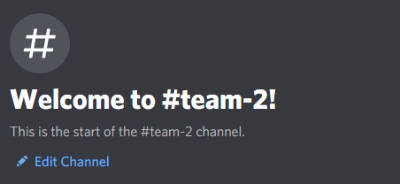

Appendix 2 – Team meetings time discussed
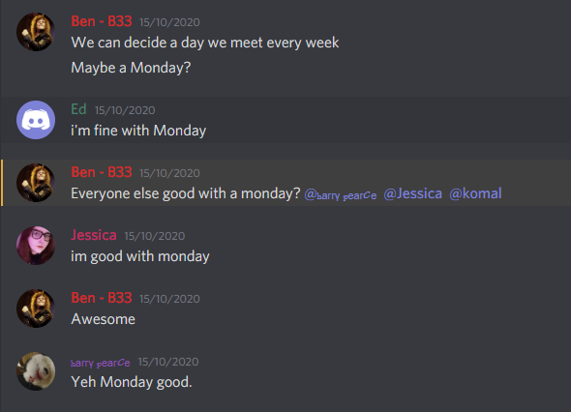

Appendix 3 – Spoken about what tasks are required to be completed
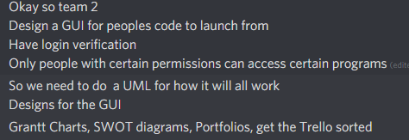

Appendix 4 – Trello board

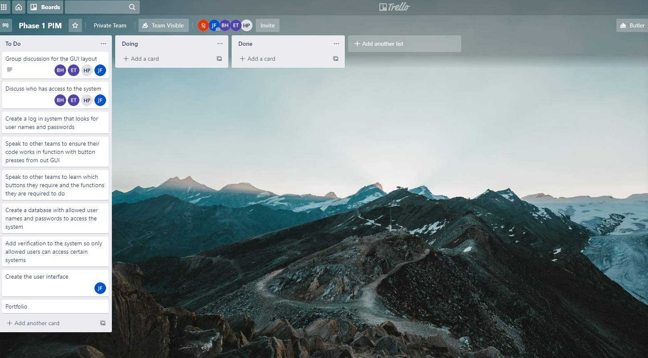

Appendix 5 – Team work assignment
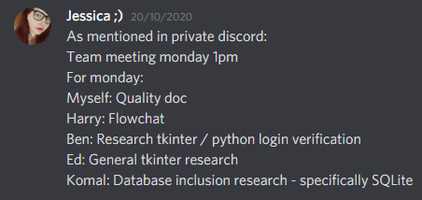

Appendix 6 – Week 4 work assignment

Appendix 7 – Week 4 Trello board
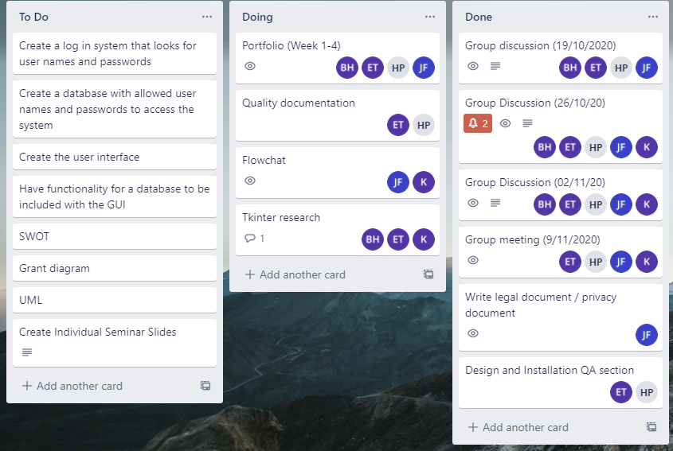

Appendix 8 – Slide show discussion
